Installation Guide
Domain Value Translation Service

 |   Center for Biomedical Informatics and Information Technology


This is a U.S. Government work. November 2nd, 2010

Contents
Introduction 2
Overview of DVTS 2
DVTS Tested Platforms 2
DVTS Software Requirements 3
Set Environment Variables 4
Set JAVA_HOME Environment Variable 4
Set ANT_HOME Environment Variable 5
Download DVTS Module 6
Install DVTS 7
Install Source and Binary Distributions 7
Install Windows Distribution 7
Verify Installation 8
Verify Binary Installation 8
Verify the Source Installation 8
Verify Windows Installation 8
Contacting NCI CBIIT Application Support 9

Introduction
This installation guide outlines the supported configurations and technical installation instructions for caAdapter Domain Value Translation Service (DVTS) module. It provides step-by-step instructions to install the CMTS module and the validating steps of post installation.

Overview of DVTS
The DVTS module is part of the integrated development caAdapter tools to support translating vocabularies between domains. Domain is a group of vocabularies within a concept category such as ‘gender’ or ‘marital status’. DVTS is provided with java API for programming, web and restful service for web access.

The DVTS module supports NCI CBIIT’s mission of creating standards-based infrastructure to facilitate medical research data exchange.

DVTS Tested Platforms
The DVTS module has been tested on the system platforms with the stated software and hardware requirements listed in Table 1.

 | NCI CBIIT Windows Server | NCI CBIIT Linux App Server
Model | DELL Optiplex 755 | HP Proliant ML 330
CPU | 1 x Intel® Core™ 2 Duo  2.66 GHz | 1 x Intel® Xeon™ Processor 2.80 GHz
Memory | 3.2 GB | 4 GB
Local Disk | System = 40 GB | System = 2 x 36 GB (RAID 1)  Data = 2 x 146 (RAID 1)
Network | 100mb / full duplex | 100mb / full duplex
OS | Windows XP 2002 Professional | Red Hat Linux ES 3
Resolution  (Recommended) | 1280 x 1024  1024 x 768 | 1600x1200  1400x1050  1280x960  1280x864
Resolution  (NOT Recommended) | 800 x 600  640 x 480 | 800 x 600  640 x 480
Table 1 DVTS Module Tested Platforms

DVTS Software Requirements
The DVTS module is implemented based on caBIG Technology Stack 2010 (https://wiki.nci.nih.gov/display/TechStack/Technology+Stack+2010). Third-party software, Table 2. to run the binary, source, and Windows distributions. The third-part software is not distributed with DVTS. You must download and install them before using the DVTS module. Visit the website below to review the license agreement.

Software Name | Version | Description/URL | Note
Java Platform Standard Edition (Java 2 Platform) | 1.6 | The Java SE 6.0 (JDK 6) supports developing and deploying Java application on desktop and servers, as well as the embedded and real-time environments.  http://www.java.com/en/download/manual.jsp | Required for all distribution to run or build DVTS module
Apache Ant | 1.7 | Ant is a Java library and command-line tool in the mission to drive processes describe in build files as targets and extension points dependent upon each other.  http://archive.apache.org/dist/ant/ | Only required for source distribution to build DVTS module.
Spring Framework | 3.0.6 | Spring Framework 3.0 is the next generation of Spring: fully Java 5 based, EL enabled, RESTful service enabled.  http://www.springsource.org | Required for web side supporting restful service.
Table 2. Required Software for DVTS Module Distributions

Set Environment Variables
You must verify that the JAVA_HOME and ANT_HOME environment variables are set and add to your PATH.

Set JAVA_HOME Environment Variable
The JAVA_HOME variable is required for all DVTS distributions. Do the following to set this variable and add it to your PATH in Windows.
Step | Action
 | Right click My Computer > Properties and select the Advanced tab.
 | Click the Environment Variables button.
 | JAVA_HOME must be listed in the User variables or System variables section of the dialog box. To add a new variable, click the New button, the New User Variable dialog box appears; To edit an existing variable, select a variable and double click it or click the Edit button, the Edit User Variable dialog box appears.
In the New User Variable dialog box or Edit User Variable dialog box, set Variable name and Variable value for your Environment Variables (JAVA_HOME).
Example:
Variable name = JAVA_HOME; Variable value = C:\jdk1.6
 | Find the PATH environment variable, double-click it or click the Edit button, and add %JAVA_HOME%\bin to the end of its value. Click all OK buttons to confirm the changes.
 | To verify that the PATH statement listed in the Environment Variables dialog box includes, open a command window (Start > Command Prompt). Type path at the prompt and hit enter to display your path. For example, C:\jdk1.6 should be at the end of your path. If you were successful, you can run java anywhere in your system. To verify the java version type java –version at the command prompt.

Set ANT_HOME Environment Variable
The ANT_HOME variable is required to build your local application with the CMTS source distribution using Apache Ant. Do the following to set this variable and add it to your PATH in Windows.
Step | Action
 | Right click My Computer > Properties and select the Advanced tab.
 | Click the Environment Variables button.
 | ANT_HOME must be listed in the User variables or System variables section of the dialog box. To add a new variable, click the New button, the New User Variable dialog box appears; To edit an existing variable, select a variable and double click it or click the Edit button, the Edit User Variable dialog box appears.
In the New User Variable dialog box or Edit User Variable dialog box, set Variable name and Variable value for your Environment Variables (ANT_HOME).
Examples:
Variable = ANT_HOME
Variable Value = C:\apache-ant-1.7
 | Find the PATH environment variable, double-click it or click the Edit button, and add %ANT_HOME%\bin to the end of its value. Click all OK buttons to confirm the changes.
 | To verify that the PATH statement listed in the Environment Variables dialog box includes ANT_HOME, open a command window (Start > Command Prompt). Type path at the prompt and press Enter to display your path. For example, C:\apache-ant-1.7\bin should be at the end of your path. If you were successful, you can run ant anywhere in your system.

Download DVTS Module
DVTS distribution can be differentiated to three modules as following
- JAR file for supporting API on client side
- SRC package
- WAR file for supporting web access (web and restful service)
Complete the following steps to download DVTS module.
Step | Action
 | Go to the NCI CBIIT download web site: http://ncicb.nci.nih.gov/download/index.jsp.
 | Enter your email, name, and institution. Click Enter the Download Area.
Select Download from the caAdapter section.
Select the box labeled Checking this box indicates that you agree to the above terms to indicate agreement with the caAdapter license.
Select the appropriate distribution as listed below and save it to a temporary directory on your computer (for example, C:\temp in Windows).
  - Binary Distribution: The DVTS binary distribution is single jar file as the minimum package for the client side API users. This contains the binary code for API execution and a few GUI tool for test running.
Binary Zip File Name | Description
caAdapter-dvts.jar | Jar file
  - Source Distribution: The DVTS source distribution file contains the source java code, build.xml, helpful documents, Release Notes, readme.txt, example context domains and licenses.
Source Zip File Name | Description
caAdapter-dvts_src.zip | Source file
- WAR File: This WAR file is necessary if user wants to construct their own DVTS web server or web based vocabulary contexts. This file contains binary code, helpful documents, Release Notes, readme.txt, example context domains, licenses and web environment files.
Binary Zip File Name | Description
Caadapter-dvts.war | WAR file

Install DVTS
Procedures for installing the source, binary, and Windows distributions of CMTS follow in this section.

Install Binary Distributions
As mentioned above, DVTS binary distribution is just single Jar file, so any special install procedure is not needed except copying to appropriate location such as ‘lib’ folder and setting environment variables such as ‘classpath’. But there is one special thing before using this file – creating context link address property file. About this property file, further explanation will be continued with another document.

Install Source Distributions
Extract the contents of DVTS source or binary distribution zip file to the directory in your file system. The selected directory will be your caAdapter home directory. For example, you can select your DVTS home directory as C:\caAdapter\dvts. Table 4 contains the structure of your DVTS home directory after installation of the source distribution. If you install the binary distribution, the build, dist, src and test directories are not created.
Directory | Contents
build | Binaries (.class files) (only for source distribution and is created at runtime)
dist | Contains .jar files (only for source distribution and is created at runtime)
doc | DVTS documentation and help system
lib | Java libraries and dependencies (empty)
src | Source code (only for source distribution and is created at installation time)
test | Batch command files and sample environment files for testing
workingspace | Default directory where you can save project files. It also contains an examples directory with sample data.
Table 3. Directory Structure of the DVTS Source and Binary Distribution

Install WAR file
Installing WAR file must follow the target web server software such as Tomcat or JBoss. JBoss is more recommended than other software.

Verify Installation
Perform the process appropriate to DVTS distribution to ensure that your installation was successful.

Verify Binary Installation
Perform the following steps to launch CMTS.
Step | Action
 | In a command prompt window, change directory to go to the Jar file located.
Enter java –classpath caAdapter-dvts.jar gov.nih.nci.caadapter.dvts.ui.ContextVOMTranslationGUI
Then, the following test GUI frame will be popped up. The error message is caused by not found any context link address property file and so this is normal. After creating an appropriate property file, if the file name is given as a argument to this commend line, this error message won’t appeared.

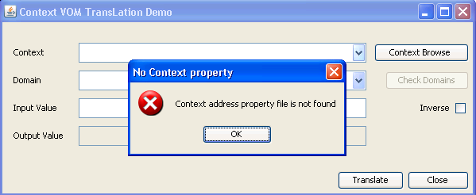

Verify the Source Installation
Perform the following steps to build your local application and launch DVTS.
Step | Action
 | In a Command Prompt window, enter cd {home_directory} to go to your DVTS home directory (for example, in Windows C:\dvtsSrc).
 | Enter ant
 | Change to dist directory, enter cd test
Enter guitest.bat
The GUI frame of the above part will be popped..

Verify WAR Installation
Perform the following steps to launch CMTS.
Step | Action
 | Shot down the platform web service
 | Move the WAR file to the appropriate directory of the platform web server
 | Restart the platform web service
Open new web browser and type linking address – this address may be vary depending on the web server package or its environment.
e.g. http://199.199.199.188:8080/caadapter-dvts/
And then, following DVTS start page will be shown.
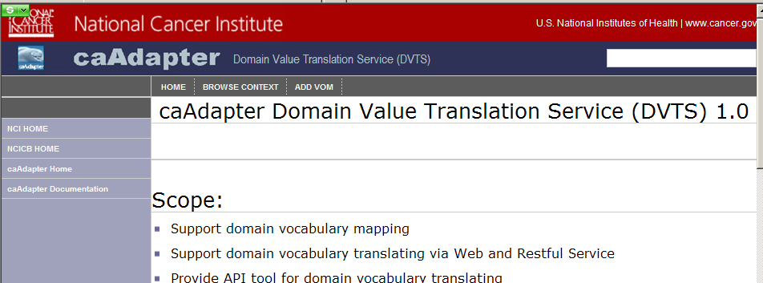

Contacting NCI CBIIT Application Support
http://ncicbsupport.nci.nih.gov/sw/
Telephone: 301-451-4384
Toll free: 888-478-4423

